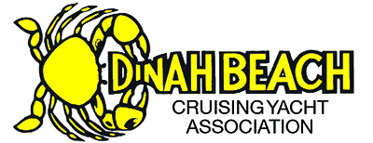
2016-17 Wet Season
Race Series Results
Season Winners
Division | Category | Winners
1 | RACING 1  Glen Lane Memorial Cup | 1ST SILVERJACK Philip Brownscombe  2ND SYNCHRONICITY Veroniquie De Vaulx
2 | RACING 2  Brian Barton Memorial Shield | 1ST GLASS ONION Peter Weir  2ND MADAM LAU John Jordan  3RD RED KNOT Bob Colman
 | CRUISING  Patrons Shield | 1ST BOUSSOLE Louise Becker  2ND EQUAL TIE:  MAJARNI Peter Suitor  BALLADIER Phil Campbell  3RD LOLLIPOP Joy Eggenhuizen

Special Awards
 | CHASTITY BELT willingness to participate but couldn’t due to unforeseen circumstances | LIQUIDITY II Greg Dix
 | IMPROVEMENT AWARD lots of promise | FRANCES CLAIRE Dean Oliver
 | CLIPPERBOAT Most firsts across start line | X FACTOR Steve Shortz
 | STERNCHASER Australia Day Race | SILVERJACK Philip Brownscombe
 | KNOB OF THE SEA heroic failures of the season | SCALLYWAG Tim Hill
 | WOODEN SPOON last placed in cruising | BEFORE THE WIND Tom Breuufeck
BEST FOODS Most firsts across finish line |  | RED KNOT Bob Colman

Prize Winner of the $8K Marine Electronics Package (by auction)
HAGAR | Jim Smith

